Student Name: __________________
Class and Section __________________
Total Points (20 pts) __________________
Due: Sep 12, 2016 before the class

Project: Geometry: point in a rectangle?

CSCI 1301 Introduction to Programming Principles
Armstrong Atlantic State University

Problem Description:

Write a program that prompts the user to enter a point (x, y) and checks whether the point is within the rectangle centered at (0, 0) with width 10 and height 5. For example, (2, 2) is inside the rectangle and (6, 4) is outside the rectangle, as shown in the Figure.

(Hint: A point is in the rectangle if its horizontal distance to (0, 0) is less than or equal to 10 / 2 and its vertical distance to (0, 0) is less than or equal to 5 / 2.)

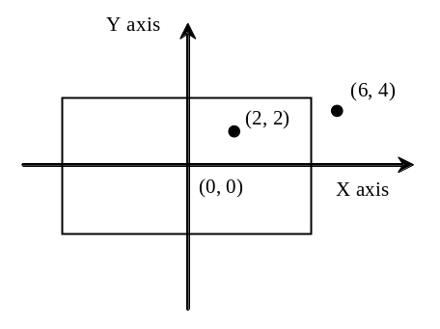

Here are sample runs of the program:

Sample 1:
Enter a point with two coordinates: 2 2
Point (2.0, 2.0) is in the rectangle

Sample 2:
Enter a point with two coordinates: 6 4
Point (6.0, 4.0) is not in the rectangle

Analysis:
(Describe the problem including input and output in your own words.)

Design:
(Describe the major steps for solving the problem.)

Coding: (Copy and Paste Source Code here. Format your code using Courier 10pts)
Name the program Exercise03_23

Testing: (Describe how you test this program)

Submit the following items:

1. Print this Word file and Submit to me before the class on the due day

2. Compile, Run, and Submit to LiveLab (you must submit the program regardless whether it complete or incomplete, correct or incorrect)

Code Solution:

import java.util.Scanner;

public class Test {
public static void main(String[] args) {
Scanner input = new Scanner(System.in);

// Enter a point with two double values
System.out.print("Enter a point with two coordinates: ");
double x = input.nextDouble();
double y = input.nextDouble();

// Compute the horizontal distance to the center of the rectangle
double hDistance = Math.pow(x * x, 0.5);

// Compute the vertical distance to the center of the rectangle
double vDistance = Math.pow(y * y, 0.5);

if (hDistance <= 5 && vDistance <= 2.5)
System.out.println("Point (" + x + ", " + y +
") is in the rectangle");
else
System.out.println("Point (" + x + ", " + y +
") is not in the rectangle");
}
}

